QUESTIONS AND ANSWERS SUPPLY AND DELIVERY OF CRM UNIFORM
No | QUESTION | ANSWER
1 | Do we need to design logo on the lining jacket as it has a financial implication? | GPAA Will provide the logo / artwork.
2 | Please advise on the type of branding preferred? | Embroidery on golf shirts; jackets and jerseys  Screen printing on scarves and ties  Golf shirt: Embroidery in white on the chest  Tie: Screen printing in white

Name badges
Description: Magnetic dome name badge
Feature: Magnet and metal material | Dome
Colour: Full colour
Size: 75mm x 30mm

Front side of the name badge

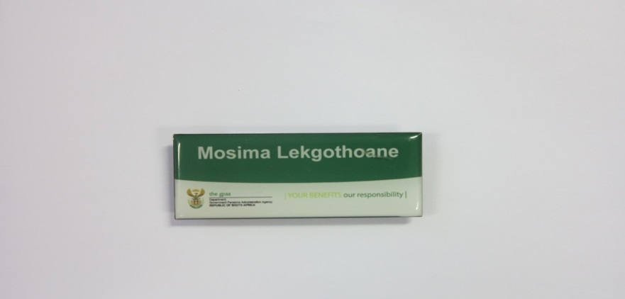

Back side of the name badge

